ER Diagram Composed Using diagrams.net
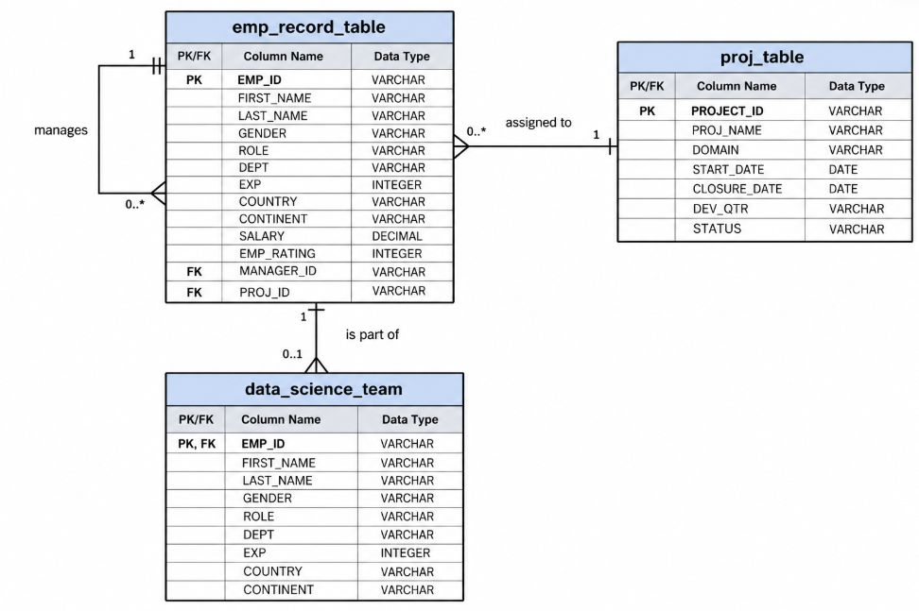

ER Diagram Composed Using Dbeaver


